K.R. MANGLAM UNIVERSITY
COURSE NAME: Computer science fundamentals and career pathways
COURSE CODE: ETCCCP105
ASSIGNMENT NO.: 03
ASSIGNMENT TITLE: Build a document and mini project using Github and VS code .
SUBMITTED BY: Varsha Pal
ROLL NO.: 2501410023
CLASS: B.TECH (CSE)
SECTION: A
SEMESTER: 01
SUBMITTED TO: MR. FEROZ AHMED
INTRIDUCTION:
In this assignment, I have created a simple Portfolio Website using HTML, CSS, Git, and GitHub
The purpose of this project is to understand how version control works and how developers use Git and GitHub to manage their code efficiently.
This assignment helped me learn:
ϖ How to create and organize project files using VS Code
ϖ How to use Git commands like git init , git add, git commit, and git push
ϖ How to upload a project to GitHub
ϖ How to maintain proper documentation using README and markdown files
ϖ How version control helps in tracking changes and improving teamwork
What is Git?
Git is a version control system. It allows developers to:
ϖ Track changes in code.
ϖ Save different versions of a project
ϖ Undo mistakes
ϖ Work in teams without overwriting each other’s work
ϖ Git helps in keeping the entire project safe and organized.
What is GitHub?
GitHub is an online platform where we can:
ϖ Store our Git projects.
ϖ Share code with others.
ϖ Collaborate with teams.
ϖ Host projects and view them from anywhere.
ϖ GitHub is widely used by companies, developers, and students for project management.
About the Project :
For this assignment, I developed a Portfolio Website. It includes:
ϖ Home page.
ϖ About section.
ϖ Skills table.
ϖ Projects section .
ϖ Contact details.
The project is fully uploaded on GitHub with multiple commits and a proper documentation folder.mple Portfolio Website using HTML, CSS, Git, and GitHub.
The purpose of this project is to understand how version control works and how developers use Git and GitHub to manage their code efficiently.
This assignment helped me learn:
ϖ How to create and organize project files using VS Code
ϖ How to use Git commands like git init, git add, git commit, and git push
ϖ How to upload a project to GitHub
ϖ How to maintain proper documentation using README and markdown files
ϖ How version control helps in tracking changes and improving teamwork.
Git commands used:
- git init:
Git init is a command used to create a new git repository in your local folder.it tells git to start track img changes in that folder and creates a hidden .git directory where git stores all version history and settings.
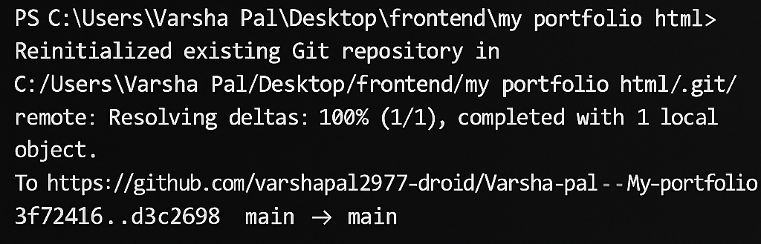
- git add
Git add is a command used to select the files you want to track or include in the next commit.it moves changes from your working folder into the staging area,preparing them to be saved permanently with a commit.
3.git commit:
git commit is a command used to save your staged changes permanently in the git repository.it records a snapshot of your project along with a message that explains what changes were made.
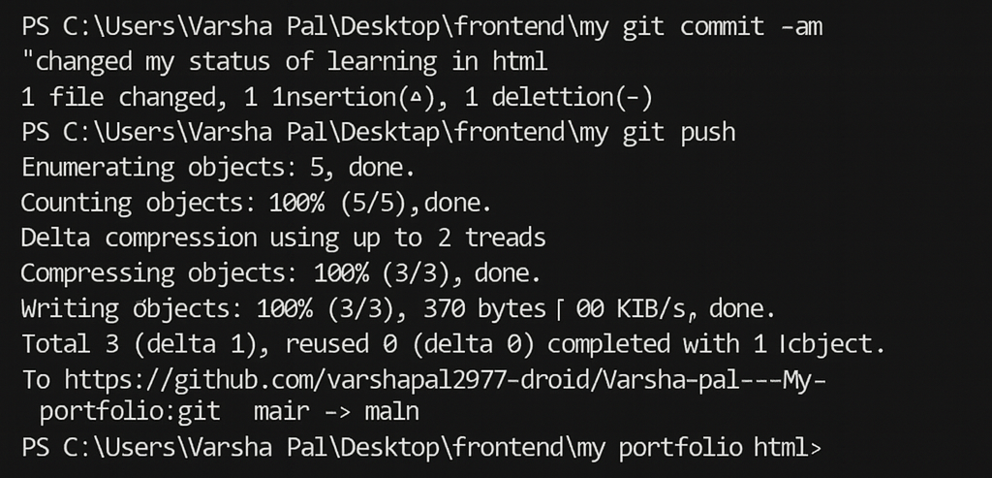
4.git push
Git push is a command used to upload your local commit to a remote repository such as github . it sends your saved changes from your computer to your online repository so others can access them.
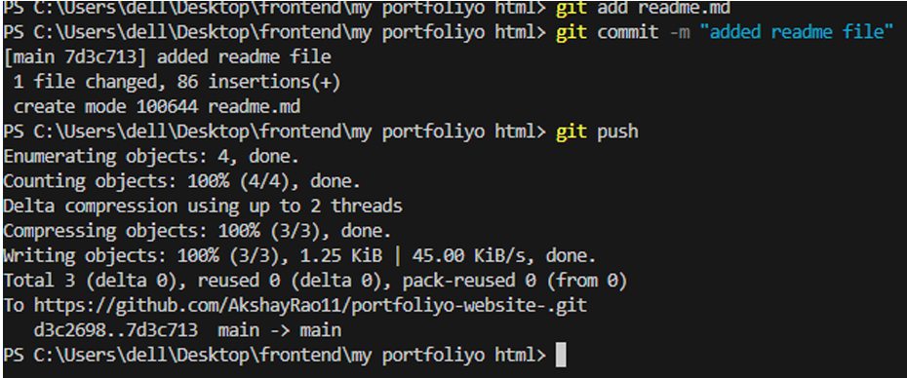
5. git status :
Git status is a git command used to show the current status of your woking directories and staging area .it tells you:
ϖ Which file are changed.
ϖ Which file are staged.
ϖ Which file are not tracked.
ϖ Whether you need to commit or not.
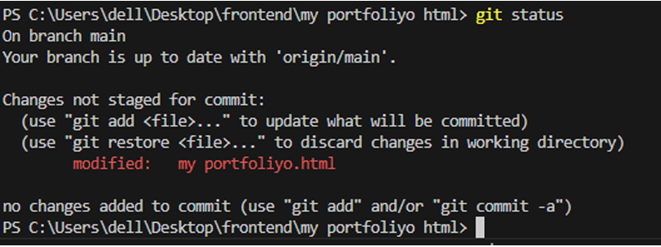
6.git –v
This command is used to check the version of your git.
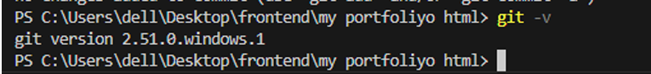
7.Git hub repository with commit changes :
https://github.com/varshapal2977-droid/Varsha-pal---My-portfolio.git
this repo includes the readme file , the git ignore file and the file containing the html code of portfolio.
Commit history :
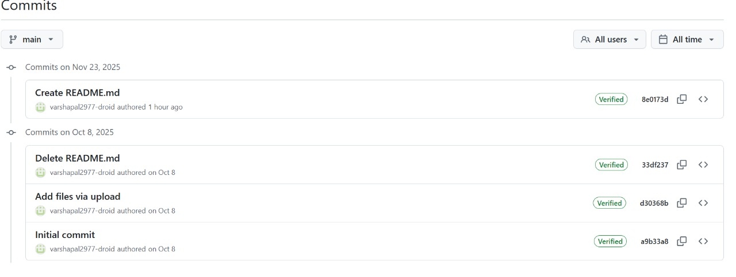
First Commit:
Secondcommit:
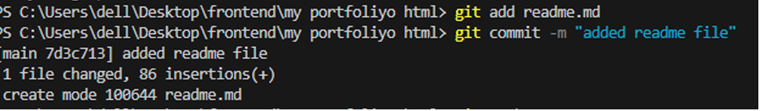
Third Commit:
fourth Commit:
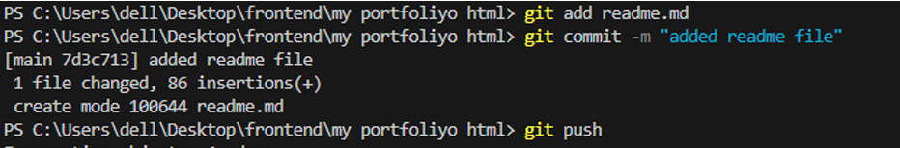
I HAD UPLOADED THE HTML CODE ,CSS CODE, README FILE , IN THE REPOSATORY WHOSE LINK I HAD ATTACHED ABOVE .

THANKYOU.

SUBMITTED TO: MR. FEROZ AHMED

